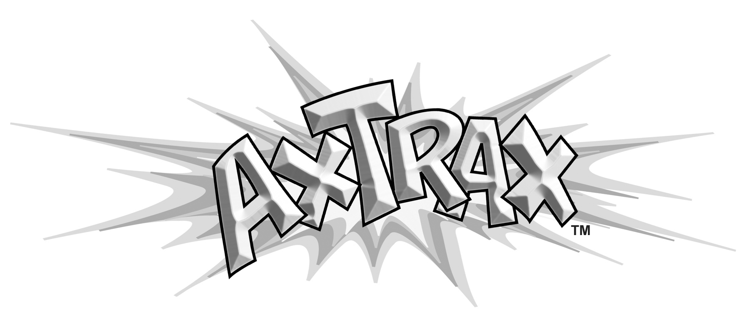

INTERACTIVE PUPPET PERFORMANCE ROUTINES
“HAPPY BIRD-DAY!” 6 min.
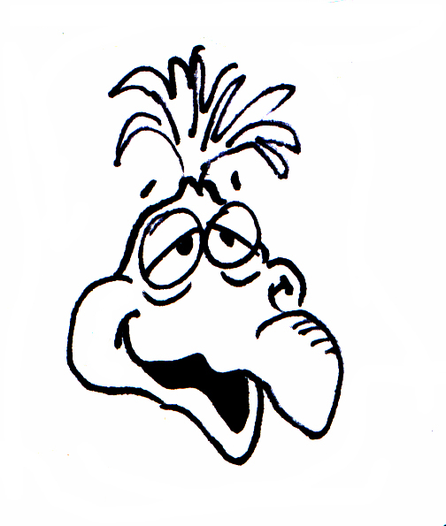

FOR USE WITH AXTELL’S BIRD PUPPETS AND THE “BIRD ARM ILLUSION”

© COPYRIGHT 2007 AXTRAX PUBLISHING
DIV. OF AXTELL EXPRESSIONS! (805) 642-7282 www.axtell.com

WRITTEN AND PERFORMED BY: STEVE AXTELL
SPECIAL CONTRIBUTORS: BILL BOLEY, GREG JACKSON & RYAN AXTELL
MUSIC SOUND EFFECTS AND ENGINEERING BY: GREG JACKSON
RECORDED AT: TREEHOUSE PRODUCTIONS and AXTELL ENTERTAINMENT

LEGAL NOTICE: By purchasing this routine you have the right to perform this routine and it’s musical components in live performances only. Not for use on television or on Video Productions without written permission. Limited Warranty of 3 weeks to replace damaged media. No refunds on electronic media.
© Copyright and Trademark Axtell Expressions, Inc. All rights reserved.

SEE OTHER AXTRAX PERFORMANCES AVAILABLE FOR PUPPETS AND THE MAGIC DRAWING BOARD AT www.axtell.com

PAUSES HAVE BEEN LEFT IN THE RECORDING TO ANTICIPATE AUDIENCE LAUGHTER
YOU CAN MODIFY THE (YOU) LINES TO FIT YOUR PERSONALITY. REWRITE AND BE CREATIVE!

SOUND ADVICE: You can perform this routine by playing the mp3 on a quality "boom box" portable stereo mp3 player in small areas, or over a professional sound system in large areas such as an auditorium or outside. Do not play on a small inexpensive player because the sound will distort when you try to play it loudly.

The mp3 should be played with plenty of volume. Kids will be laughing hard and will miss the routine if it is too quiet, and adults may keep laughter to a minimum for fear of missing parts of the program. The volume of the player should be set about the same as if you were speaking over a microphone to be heard by the group, or louder.

It is best to have the mp3 played over a public address system and have the soundman preset the volume level to be compatible with your microphone level.

You may want to actively pause the mp3 during your performance in case you get a large audience laugh (we hope you do) after one of the jokes.
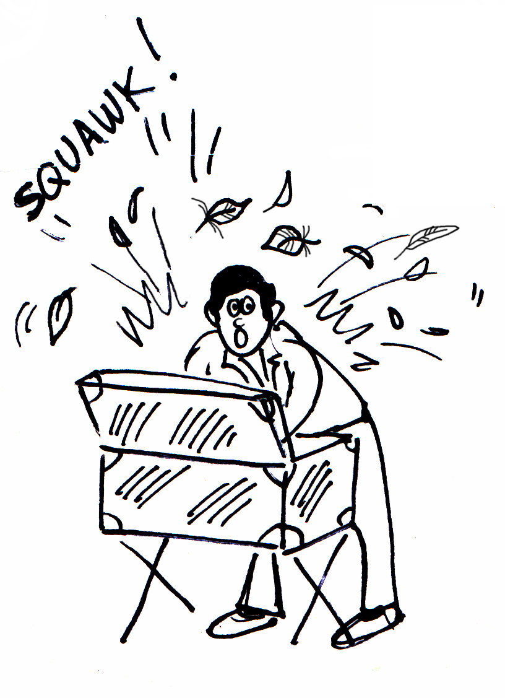

YOU: Boys and girls, I have a treat for you today. I just bought a talking bird. Would you like to see him? Okay, I’ll bring him out in a minute, but first I’m going to slip on these gloves because he’s still a little bit wild and I’ll be right back.

OPENING MUSIC

(Go get the Bird and Arm Illusion on)

DURING MUSIC - Go to your cover of a trunk lid etc. And while you put on the bird arm illusion and puppet, act like you are struggling with the bird and throw some feathers up into the air. You can get colored feathers from any craft shop. Make your bird squawk and carry on from behind a cover, then slowly come out with the bird, holding him by the chest as if to keep him from flying away.

You can also make the Arm and Puppet very easy to slip into by setting up yours in the following manner: Mount the bird arm to a coffee can (with both ends cut out) or similar rigid tube. Attach Velcro around the can, put the bird puppet on over the can and the bird arm strap. Your bird is now one unit with the can and arm. You can slip into the can quite quickly this way!
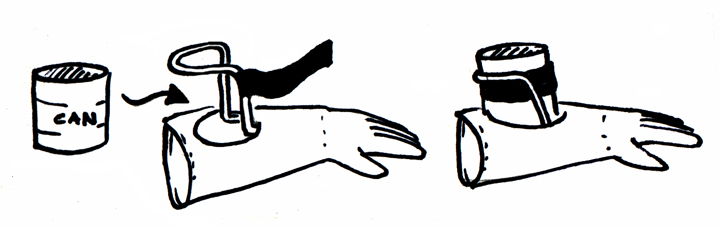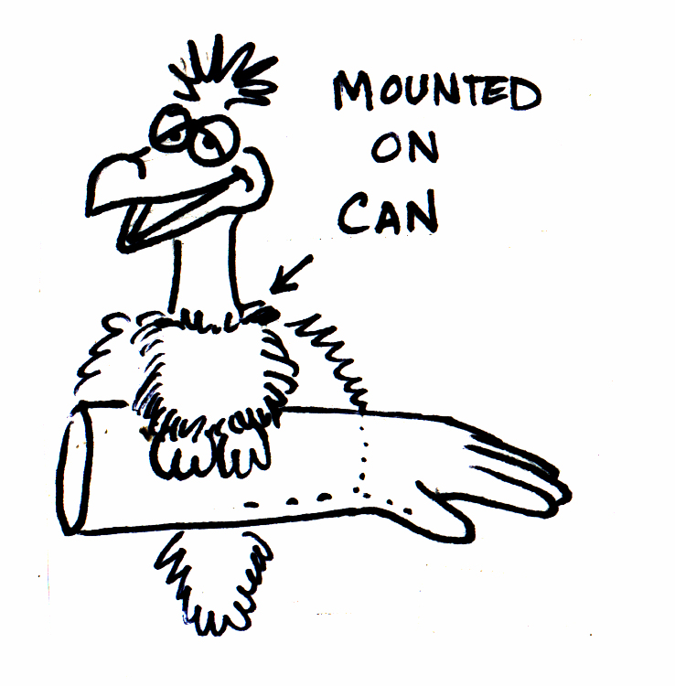

NOTE: You will get a laugh when you bring out the goofy puppet bird because of your big build up. The visual contrast is very funny.

YOU: This is my pet bird. Can you say “hello” to the folks?

BIRD: Hello to the folks! Ha ha ha ha ha ha ha (LAUGHTER)

YOU: No, just say “hi” to them.

BIRD: Hi to them. Ha ha ha ha ha (LAUGHTER)

YOU: No, don’t repeat me - just say the word “hello” and that’s all.

BIRD: Hello and that’s all. Ha ha ha ha ha ha! (LAUGHTER)

YOU: Ooh! Everyone, this is (name of puppet), and I’ve taught him to sing a special song for your birthday party.

BIRD: Hey, aren’t you going to tell them your name?

YOU: Surely.

BIRD: Your name’s Shirley?

YOU: (Name of puppet), first I’ll tell them my name and then you can sing your song. My name is…

BIRD: I am a bird, (Honk honk)
I am a bird, (honk honk)
I am a bird, I am a bird, I am a bird.

I have feathers in my nose
And in-between my toes,
I’m a bird, I’m a bird, I’m a bird! (Honk) (LAUGHTER)

NOTE: Press beak on your shoulder on honks. Make the last honk BIG and have the bird look directly up at your face for a reaction. Have an irritated look. During the song, look back and forth between the bird and audience, bewildered.

YOU: Now stop that. I’m trying to tell the audience what my name is.

BIRD: I just love to sing…ha, ha, ha. (LAUGHTER)

YOU: I know you do, and I’ll have you sing right after I tell them my name.

BIRD: Well, don’t let me stop you.

YOU: My name is......

NOTE: Make your sentence slower or longer. Continue until he actually interrupts you. There should not be a break between your live voice and his interruption.

BIRD: I’m not going to bother you, huh uh. Ha, ha, ha (LAUGHTER)

YOU: (VERY FRUSTRATED) My name......

BIRD: I’m just going to sit here and keep my beak shut. Ha ha ha ha.

YOU: (Name of puppet) , PLEASE BE QUIET SO I CAN TELL THEM MY NAME!
(Very frustrated, huffing and puffing - grabbing your own face)

NOTE: continue to be frustrated through his lines up until he starts to relax you.

BIRD: Hey, calm down there ...relax...come on, get a grip...hey, don’t fall to pieces.......hey, take a few deep breaths deep like this ( deep breaths 2 times)

YOU: (Deep breath)

BIRD: There now, take another one.

YOU: (Another deep breath)

BIRD: Now, are you all calm and relaxed?

YOU: (Very relaxed) Yes, a... thank you.

BIRD: Now, just go ahead and tell ‘em your name.

YOU: (Exhale) Okay, my name is.....

BIRD: I am a bird, (honk honk)
I am a bird, (honk honk)
I am a bird, I am a bird, I am a...

NOTE: Jump when the bird starts to sing.

YOU: (Close his beak and quiet him)
Are you finished?

NOTE- Do not grab the bird too hard or too tight, do not look too angry in the face. Kids will be watching very intently during this bit of physical play. Do it more in a fun fashion like you are quieting a child acting silly. Make it real funny, not violent, or you may scare a little child and ruin your show. Also parents may complain of being too rough.

BIRD: (Muffled) Mm-hum.

YOU: (Still holding beak) My name is (your name). (Sigh of relief - let go of bird’s beak)

BIRD: What took you so long? Ha ha ha ha ha ha (LAUGHTER)

YOU: Oh (name of puppet)!

BIRD: Hey, why are they all staring at us? (LAUGHTER)

YOU: Well, we’re all here at this birthday party....

BIRD: A BIRD - DAY PARTY, FOR ME?

YOU: No, not a BIRD-day party - a BIRTH- day party.

BIRD: Well, that’s what I said, so you’re having a BIRD-day party for me. Ha ha, well thank you, thank you, thank you! Ha ha ha ha ha ha (LAUGHTER)

YOU: NOT BIRD…BIRTH!!! B-I-R-T-H!

BIRD: ...spells “bird” ...and I’m the only bird here!

I am a bird.
I am a bird.
I am a b... (close beak)

YOU: (Name of puppet), STOP! This party is not for you.

BIRD: Oh, you mean there is another bird here? (Looking around) (LAUGHTER)

YOU: Okay (name of puppet), look. Look at this kid right here. This is (name of birthday kid)

BIRD: Well, they don’t look like a bird to me (LAUGHTER)

YOU: (Name of puppet)!

BIRD: They don’t have any feathers. (LAUGHTER)

YOU: (Name of puppet)!!

BIRD: (To child) Do you like to eat worms? (LAUGHTER)

YOU: (Name of puppet)!!!

BIRD: Well, let’s see you lay an egg then! (LAUGHTER)

YOU: (Name of puppet)! They’re not a bird! And this is not a BIRD-day party, it’s a BIRTH-day party. You see, this child is having a party to celebrate their birth.

BIRD: Well, congradja....congradja.......good fer you! Ha ha ha! (LAUGHTER)
So when did you hatch? (LAUGHTER)

YOU: They didn’t hatch....hey (name of puppet), okay look, could you just sing “Happy Birthday” to them?

BIRD: Happy bird-day? Even though they are not a bird? (LAUGHTER)

YOU: (Sigh) Ahhhhh......yes, just sing the song, PLEASE!

NOTE: He just wore you out. Roll your eyes in an “I give up” manner.

BIRD: Sure…Hit it, maestro.

(piano roll)

NOTE: You do a double take at the tape recorder and then to audience. Very cartoony reaction,
like you are shocked that it is cooperating with your bird. Shocked.

BIRD: Me, Me, Me…

NOTE: You squint at his off key voice. Like eating a lemon.

(piano roll and 3 notes)

Me, Me, Me…

(3 off key piano roll)

There you go, perfect! (LAUGHTER)

Happy BIRD – day…

YOU: BIRTHDAY!

NOTE: when you correct him you can touch him and have him glance at you, but he continues to go on in his silliness.

BIRD: to me…

YOU: Not to you - to them! (POINT)

BIRD: Happy bird-day to them. (LAUGHTER)
Happy bird-day...even though you aren’t a real bird…

and now the big finish!...

Happy bird-day to........ you!

Ha, ha, ha, ha…I just love Bird-day parties!

NOTE: You are so embarrassed at this display that you are just shaking your head back and forth either
looking at the ground or closing your eyes, like you are getting a headache, and finally he honks his nose on you and you jump again.

YOU: Thank you, (name of puppet). Let’s all give t(name of puppet) a big hand! Ha, ha, ha.

(Take off arm illusion and bird behind some cover, or exit.)

CLOSING MUSIC

THE END

NOTE: This makes a wonderful ending or opening for your birthday show.

